# **Introduction**

## Subjects

* Manage Azure identities and governance
* Implement and manage storage
* Deploy and manage Azure compute resources
* Configure and manage virtual networking
* Monitor and back up Azure resources

# **Overview of Azure Services**

## Compute Options

* 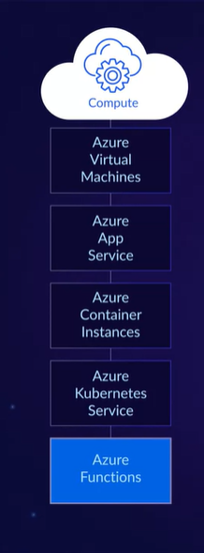

## Storage Options

* 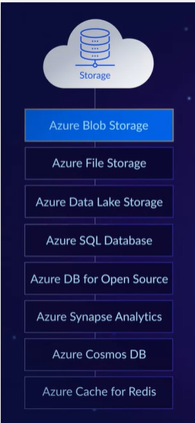

## Networking

* 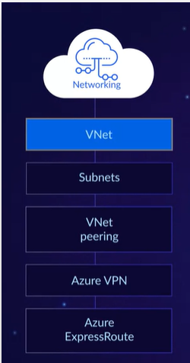

## Management

* 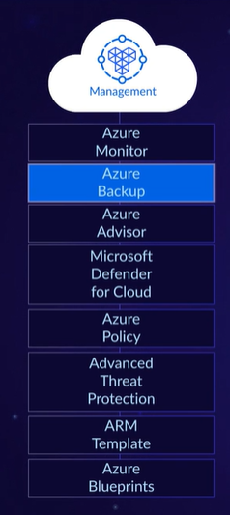

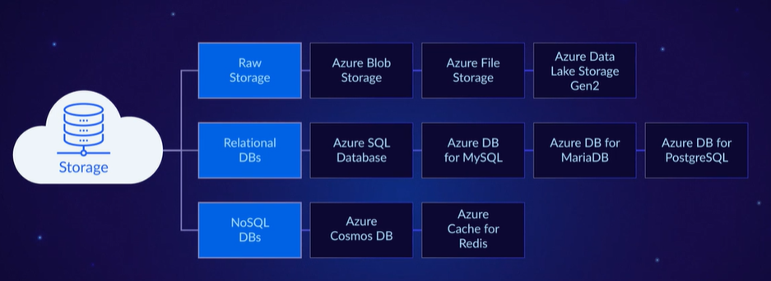

# **STORAGE ACCOUNT**

* It is a container that has all my storage objects like, blob storage, azure files, queue storage, table, and disks.
* It must be a unique name because it can be accessible anywhere around the world.

General Purpose V2

* It’s a basic account that can use in blobs, files, queues, and tables.

General Purpose V1

* Its legacy also can use blobs, files, queues, and tables. It will probably be out of support in the future

## Block Blob Storage

* Premium performance for block blobs and append blobs.
* Used for situations where high transaction rates are in play.
* For scenarios that require low storage latency.

## File Storage

* Files-Only storage accounts.
* For applications

## Blob Storage

* A legacy account used for blob-only storage.
* It’s recommended to use general-purpose V2 account instead.

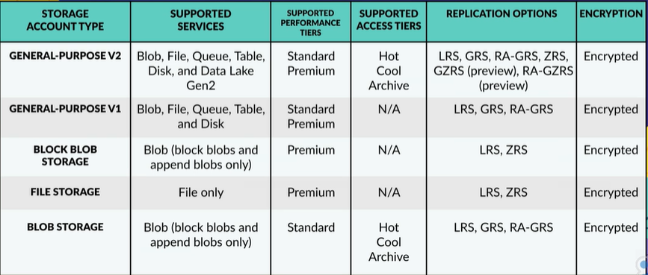

[Storage account overview - Azure Storage | Microsoft Learn](https://learn.microsoft.com/en-us/azure/storage/common/storage-account-overview)

# **AZURE STORAGE**

## Azure Blobs (Containers)

* Optimize to support massive amount unstructured data, included text and binary data.
* For photos, files, backup data.
* Tiers: Hot, Cold, Archive
* Can be access by HTTP and HTTPS, by Azure Storage Rest API, PowerShell, Azure CLI

## Azure Files

* File Share by the protocol SMB (Server Message Protocol)
* Azure File Sync, speed data access
* It’s a PaaS
* Azure Files can now completely replace traditional on-prem file servers and even NAS devices.

## Azure Queues

* To communicate distributed applications.
* By HTTP or HTTPS.
* URL to access it.
* Store large number of messages.
* Asynchronous messages between apps.

## Azure Table Storage

* Allows to store structured NoSQL data.
* Key/attribute store with a schema-less design.
* It looks is to save user data, like usernames, address books or device information.
* It can be accessed by URL.
* Doesn’t force a schema, meaning a single table can contain all kinds of entities with different properties, like name, number, age, etc.
* An entity is like a database row.
* The entity will be like name/value format.
* 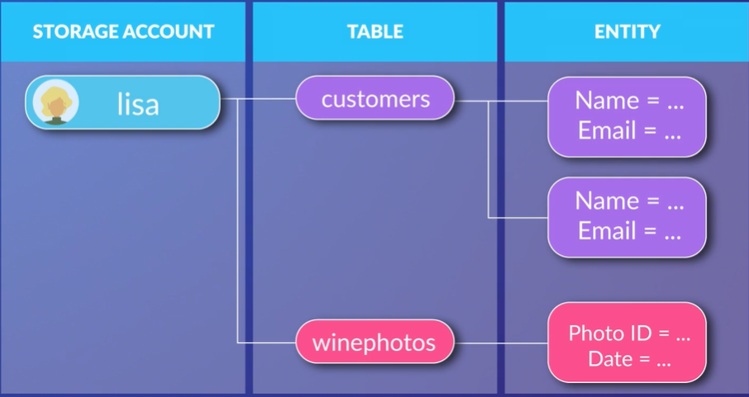

# Managed Disks

* Its like a physical disk
* Block level storage volume

# Page Blob

# Append Blob

# Block Blob

# Knowledge Check Azure Storage

## Which Azure storage type supports managing asynchronous tasks and building process workflows?

* Queue storage

## What is one reason to use a Shared Access Signature SAS instead of an account key?

* To provide access to a client that can’t be trusted with the account key.

## Which of the following Azure Storage blob types is the most suitable for logging data from Azure VMs?

* Append blob

## Which Azure Storage Encryption method provides encryption for data at rest, and its enabled by default for all managed disks, and whenever possible, snapshots, and images?

* SSE, Server-Side Encryption

## Regarding Microsoft Azure Storage, Table storage offers ______________.

* a NoSQL data store

## Which type of storage within Azure Storage is optimized for random access files that are frequently updated?

* Page Blobs

## What Azure storage method allow you to take a “point-in-time” version of your blob storage account, and supports both managed and unmanaged disks?

* Snapshots

# AZURE BLOB STORAGE

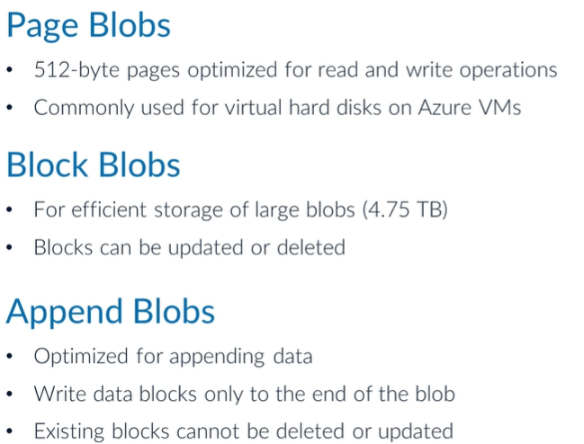

Blob lease***

## Which blob type is optimized for IaaS virtual machines?